**PERFORMANCE STANDARD**

**FORM 1**

|  |  |
| --- | --- |
| Learning Outcome | 2.2 (b) Process information by extracting  main ideas and supporting details.    Level 2 (viii) :  Reading and understanding non-linear  texts using simple diagrams and tables. |
| Band | 4 |
| Performance Standard | B4  Apply knowledge acquired in a variety of situations using some appropriate language conventions |
| Descriptor | B4 DB1  Reading and processing information in a linear / non-linear text |
| Evidence | B4 DB1E1  Able to identify cause and effect relationships in a factual / narrative text by   * extracting specific information * answering comprehension questions in complete sentences using appropriate conjunctions |

**STUDENT’S COPY**

**B4 DB1E1**

17 September…

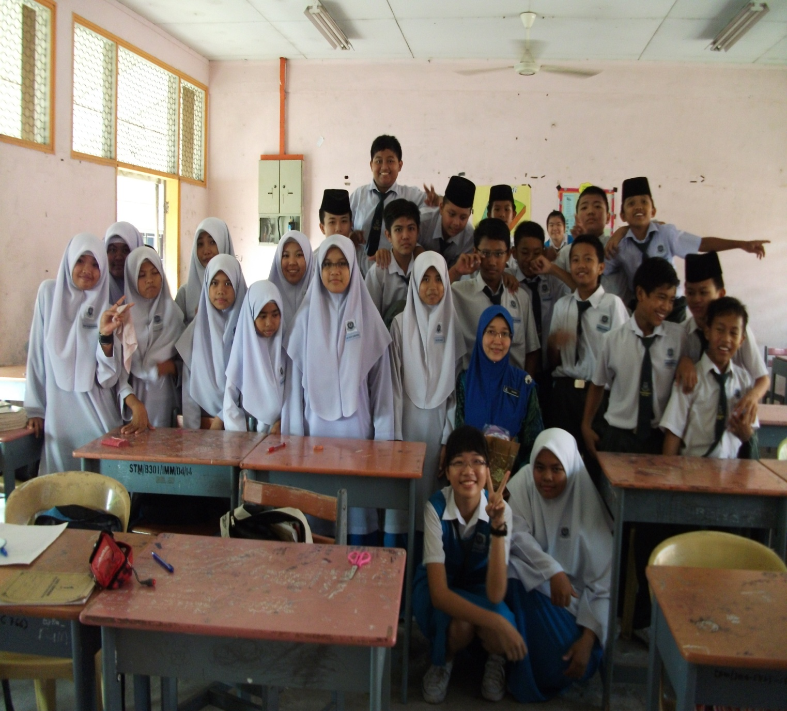Tuesday

Our class had a meeting to plan a trip to Johor for the school holidays in November.

Our form teacher Encik Azman Taufik and our Geography teacher Puan Leong will be going with **us**. **They** will help to arrange accommodation in a school hostel. They reminded us to ask the principal for permission first. Rashid and Siew Yin will see **him** tomorrow.

The students wanted to visit different places. Most of **them** wanted to have an enjoyable holiday and at the same time learn more about the occupations of people in Johor. Finally we agreed on the following places:

- a pineapple factory near Pontian

- a pottery factory in Ayer Hitam

- Kukup – a fishing village.

The class elected a committee of six members. Each member was given duties to carry out before the next meeting.

- Rashid and Hock Seng will be responsible for transport. They will find out the cost of hiring a bus.

- Zailan and Siew Yin will write letters to the two factories.

- Elizabeth and **I** will prepare the menu. **We** will also calculate the cost of food so that the committee can prepare the budget.

There will be a committee meeting next month to plan the itinerary,budget, duty roster and rules.

Written by Rohani Bt. Gazali.

**Instructions :**

**Read this page in the class journal.**

**STUDENT’S COPY**

**B4 DB1E1**

**Understanding what you read.**

1. Arrange the planning steps in the right sequence.

Hold the next meeting.

Write to factories.

Get the principals permission.

Hire a bus.

1. What do the committee members have to do before the next meeting?

Complete the chart.

|  |  |
| --- | --- |
| Committee members | Duties |
| Rashid and Hock Seng | ……. |
| ……. | ……. |
| ……. | ……. |

1. Match the words with the notes.
2. roster b. itinerary c. budget

i ii iii

***Duty*** **Person**

*1.Draw Posters Lela*

*2.Collect money Peter*

*Bus fare – RM30*

*Food - RM50*

*Hotel - RM80*

*3rd Nov.*

*- Depart for Johor*

*4th Nov.*

*- Visit pineapple factory*

1. Make a list of words that you can think of when you see each of these words. Work in groups.

C:\Program Files\Microsoft Office\MEDIA\CAGCAT10\j0183328.wmf

**Instructions :**

**Answer questions No. 1 - 4**

**TEACHER’S COPY**

**B4 DB1E1**

**Understanding what you read :** Answer the questions below.

1. Arrange the planning steps in the right sequence.

Get the principals permission.

Hold the next meeting.

C:\Program Files\Microsoft Office\MEDIA\CAGCAT10\j0183328.wmf

Hire a bus.

Write to factories.

1. What do the committee members have to do before the next meeting?

Complete the chart.

|  |  |
| --- | --- |
| Committee members | Duties |
| Rashid and Hock Seng | Responsible for transport  Find out the cost of hiring a bus |
| Zailan and Siew Yin | Write letters to the two factories |
| Elizabeth and Rohani | Prepare the menu .  Calculate the food cost. |

1. Match the words with the notes.
2. **itinerary** b. **budget** c. **roster**

i ii iii

***Duty*** **Person**

*1.Draw Posters Lela*

*2.Collect money Peter*

*Bus fare – RM30*

*Food - RM50*

*Hotel - RM80*

*3rd Nov.*

*- Depart for Johor*

*4th Nov.*

*- Visit pineapple factory*

1. Make a list of words that you can think of when you see each of these words. Work in groups.