PERFORMANCE STANDARD

Descriptor : B5 DL1
Evidence : B5 DL1 E1

Band | 5
Performance Standard | Demonstrate the ability to use language in a variety of situations using largely appropriate language conventions
Descriptor | Recounting events that took place
Evidence | Able to recount a public event

Student’s Copy

Descriptor : B5 DL1 Name :……………………..……
Evidence : B5 DL1 E1 Form : 2…………

Instruction:
Last school holidays, you went to a bird park. Recount orally about your visit to the bird park. Use the picture and notes given as a guide.

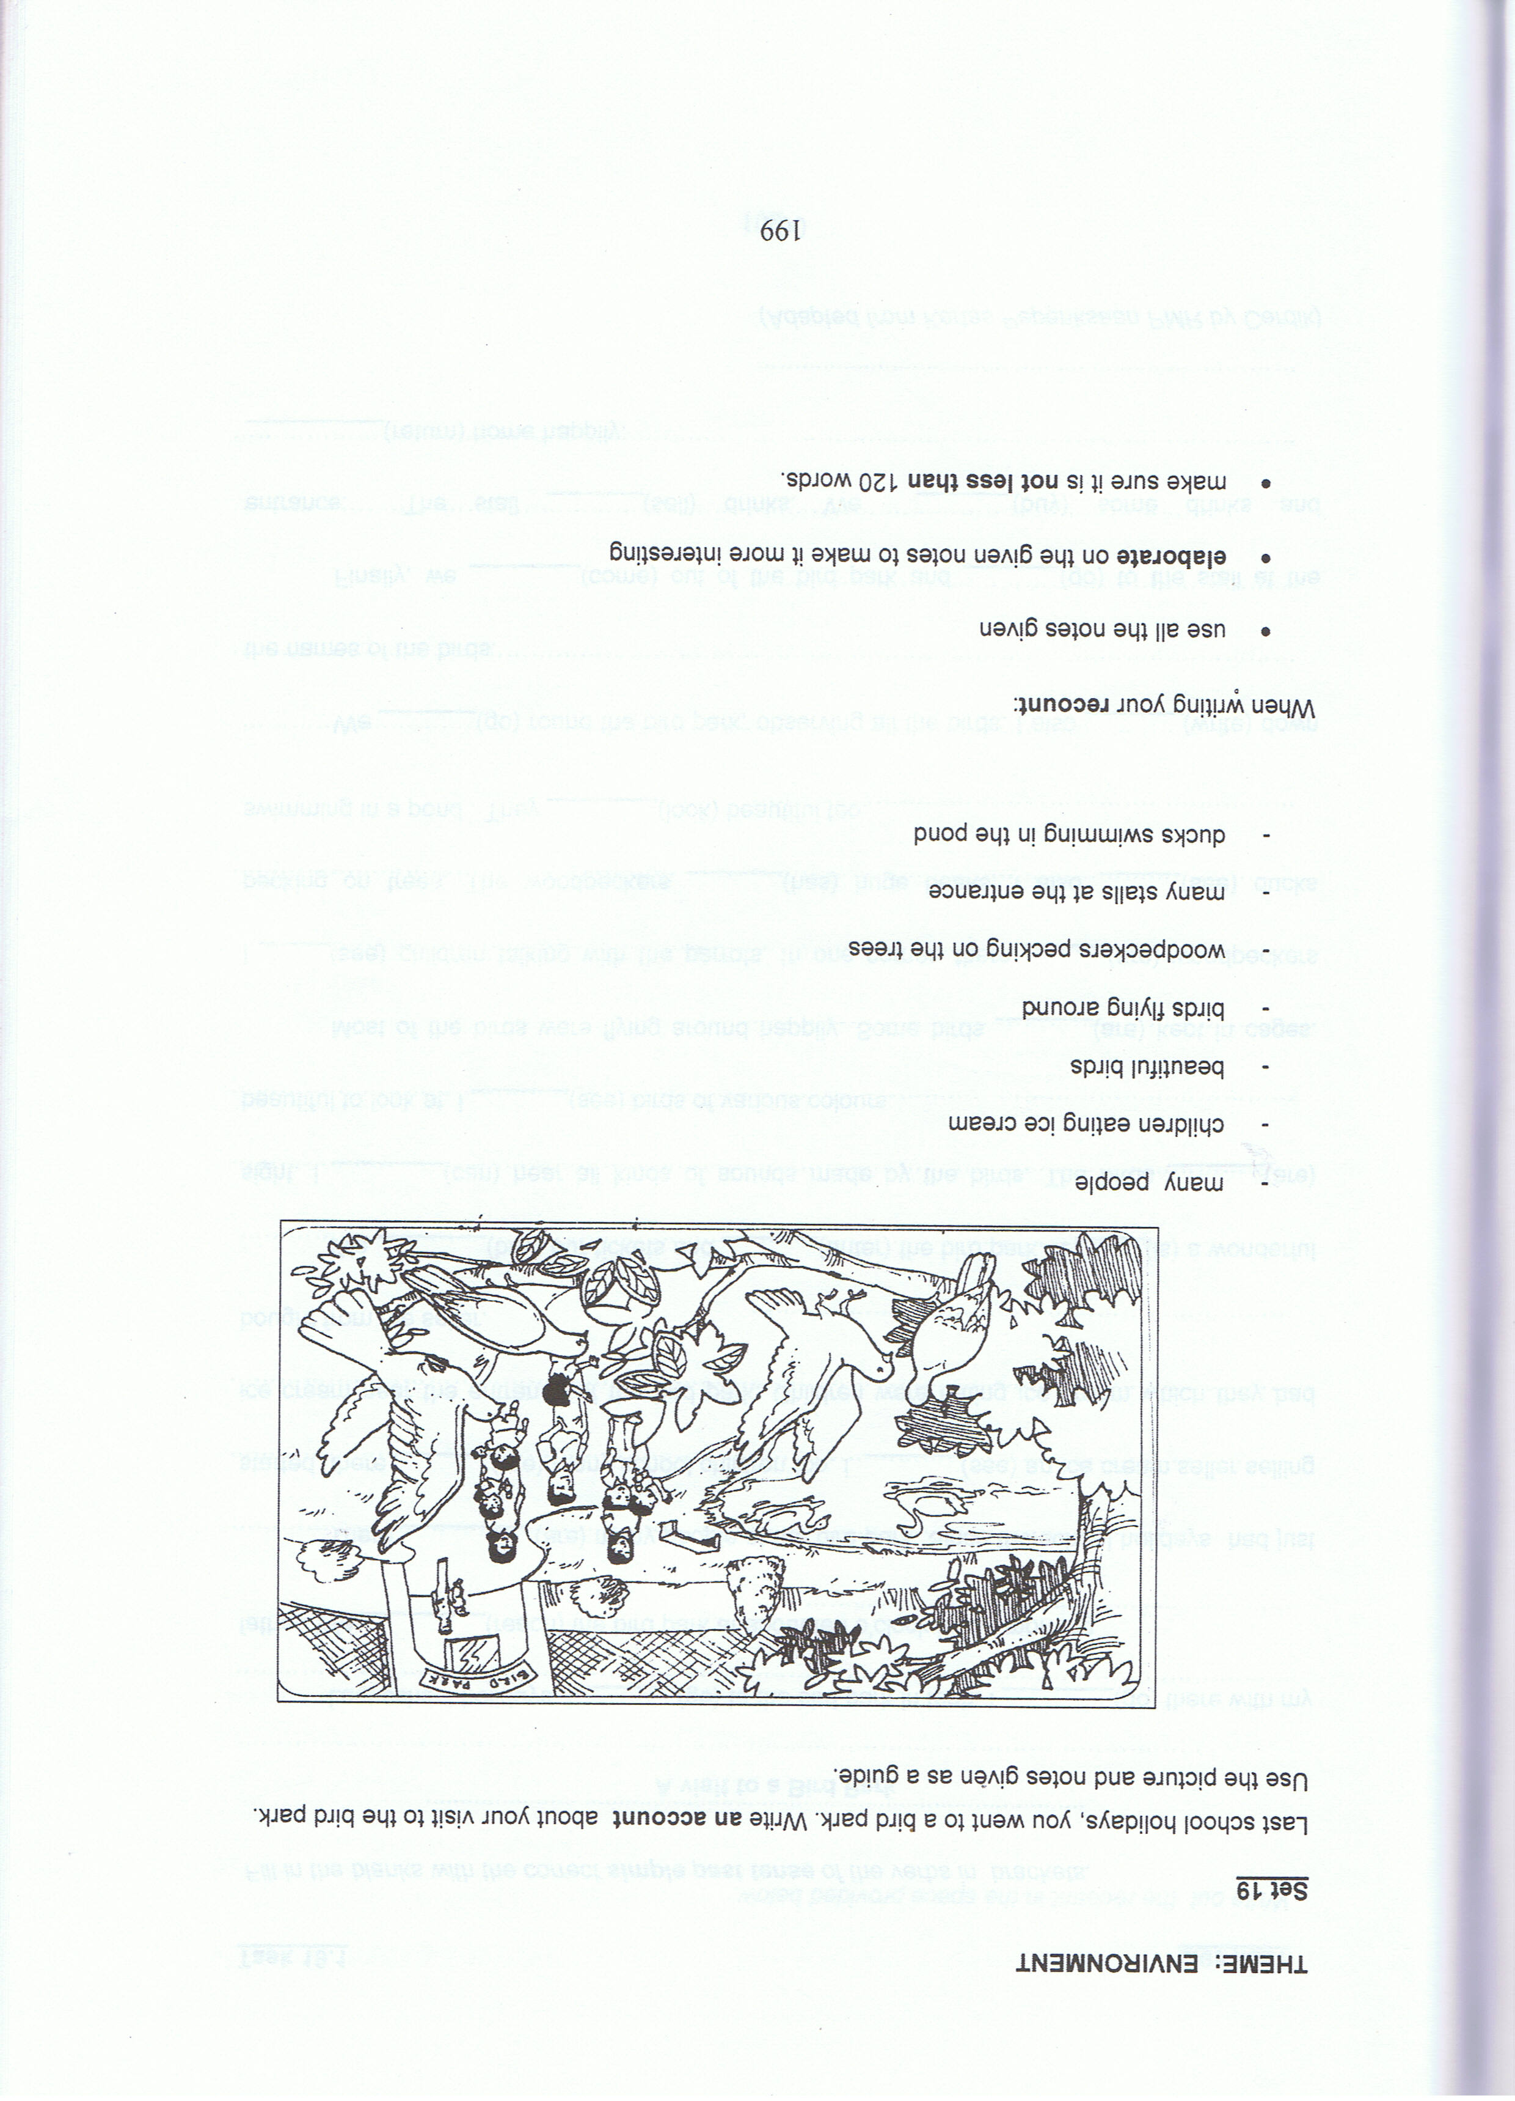

Notes:
- many people
- Children eating ice-cream
- beautiful birds
- birds flying around
- woodpeckers pecking on the trees
- Many stalls at the entrance
- ducks swimming in the pond

Teacher’s Copy

Descriptor : B5 DL1
Evidence : B5 DL1 E1

Instruction:
1. Allow students to study the picture and the notes given (for about 10 minutes)
2. Students to present their recount in their respective group or before the class individually.
3. Prior knowledge – Chapter 12 (pg 160) – A Visit to Happy Agrofarm.

Last school holidays, you went to a bird park. Recount orally about your visit to the bird park. Use the picture and notes given as a guide.

Notes:
- many people
- Children eating ice-cream
- beautiful birds
- birds flying around
- woodpeckers pecking on the trees
- Many stalls at the entrance
- ducks swimming in the pond

